21st June 2026
Agentic Fundamentals (Reflex → Reasoning) Live Class with Yadhu

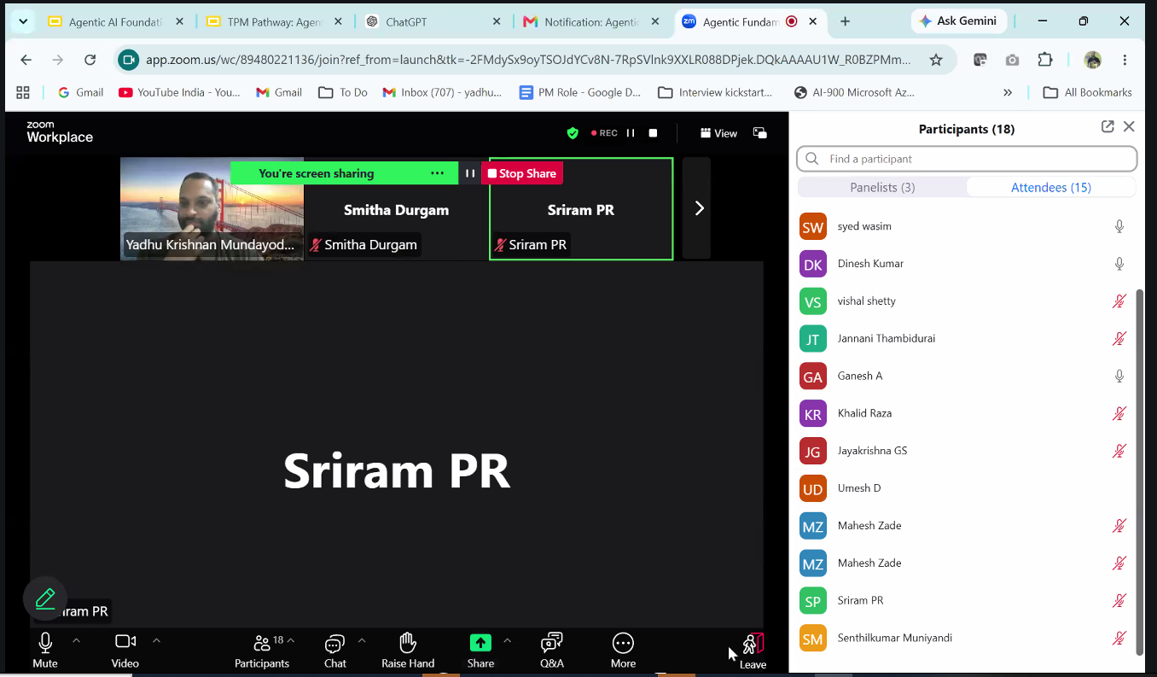
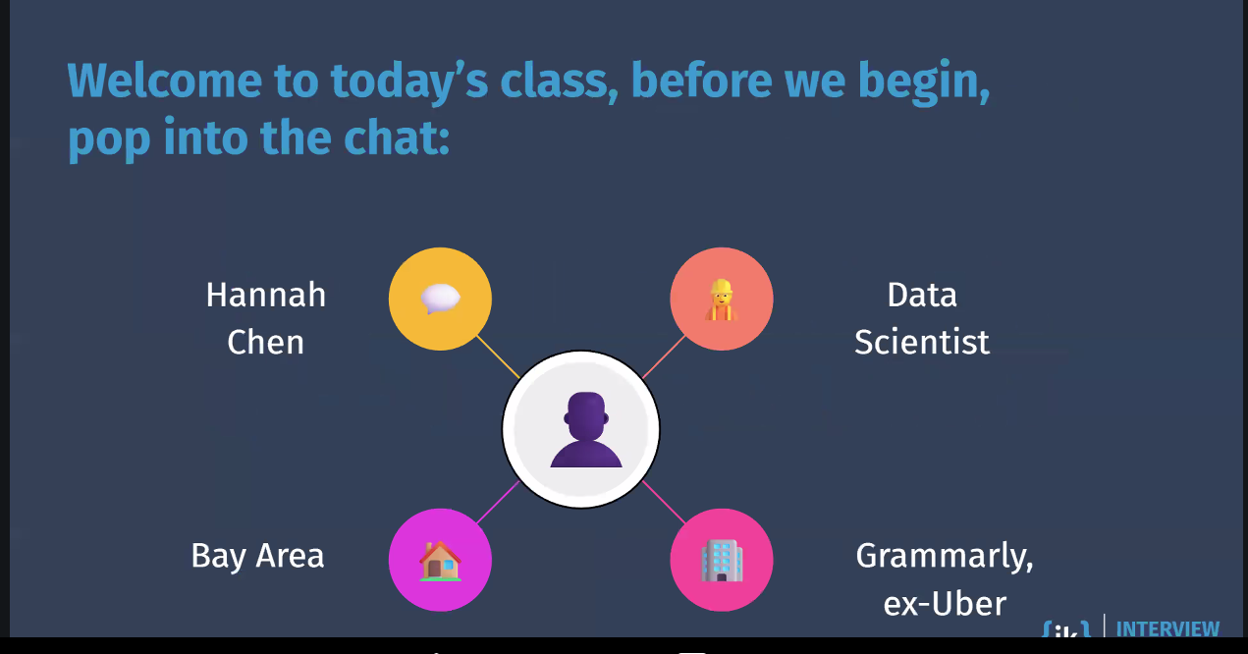
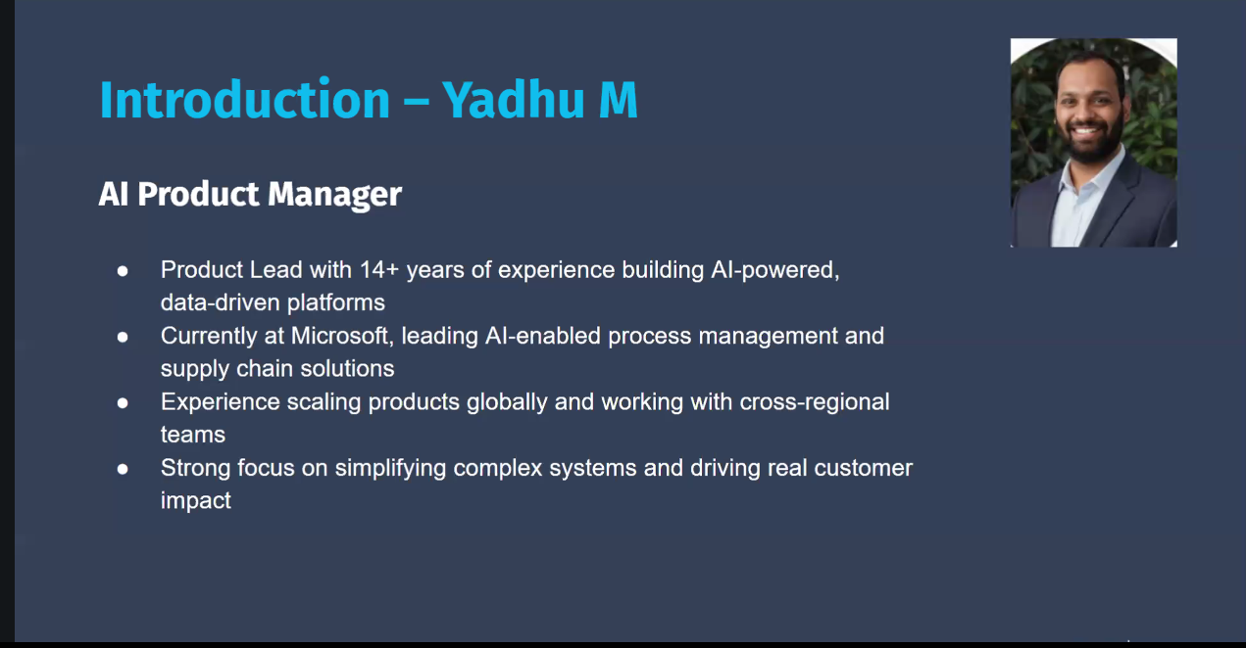

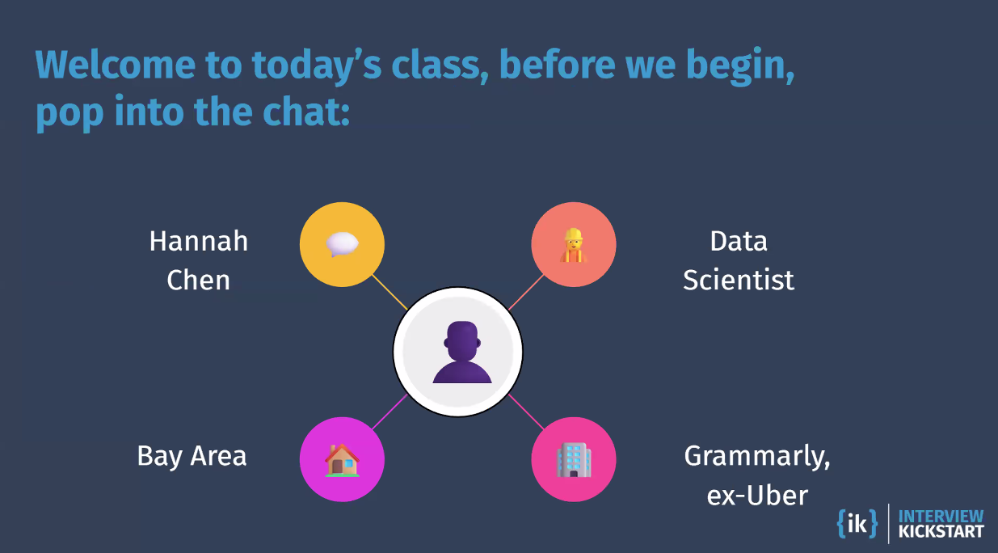
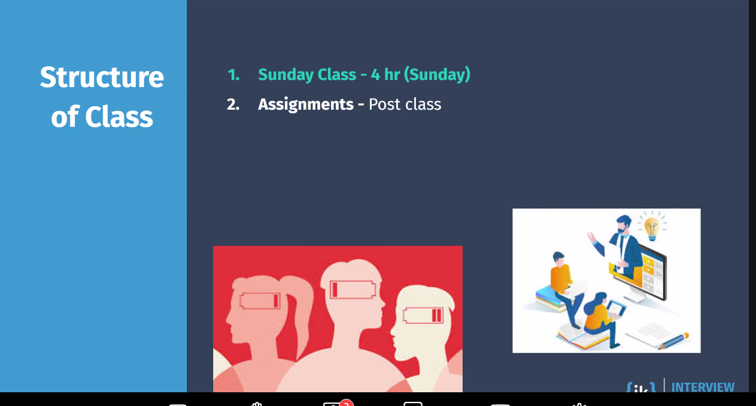

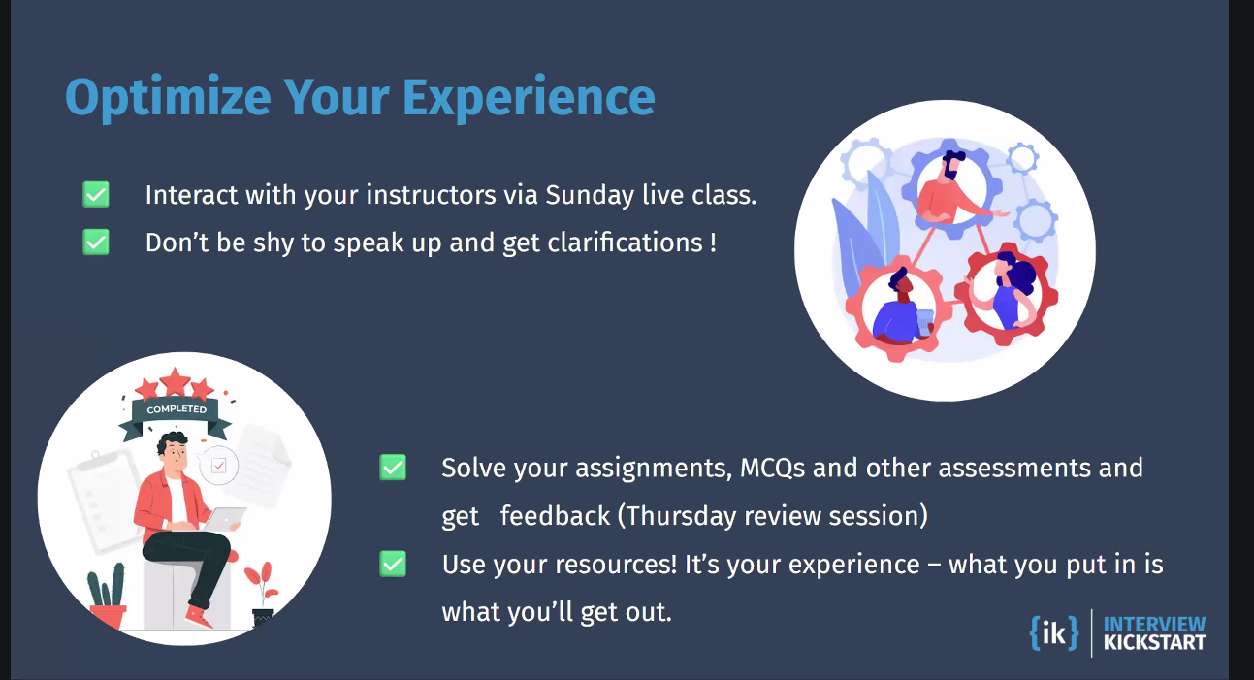
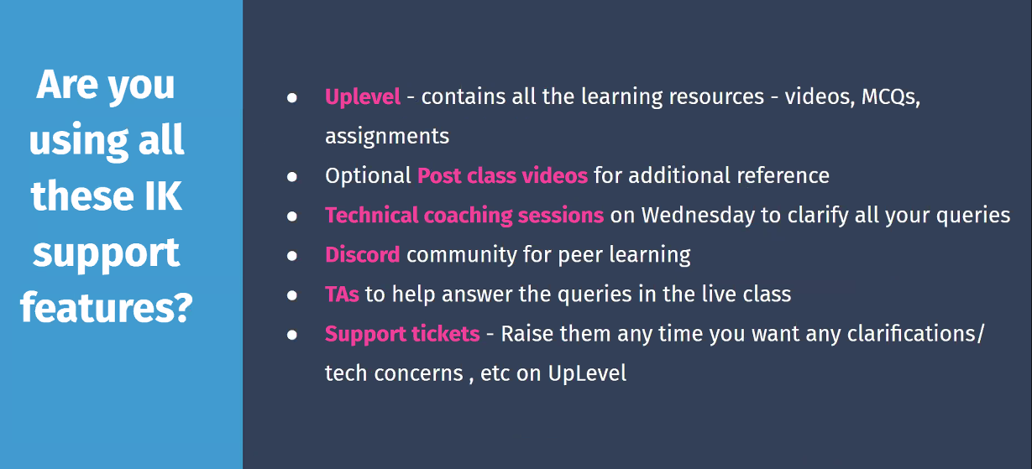
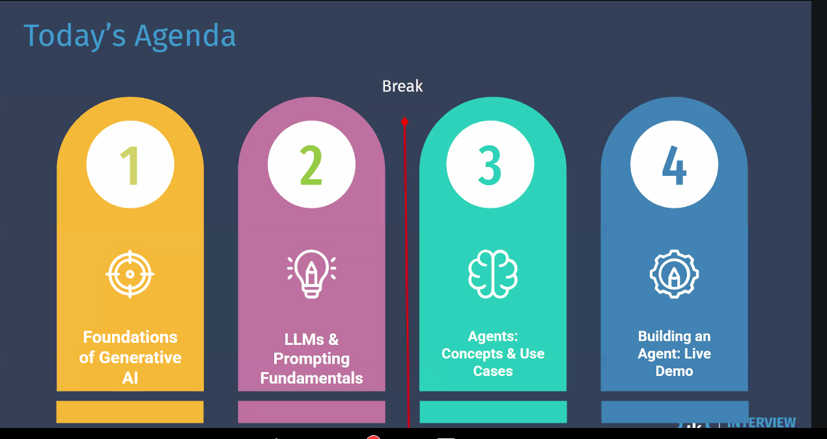
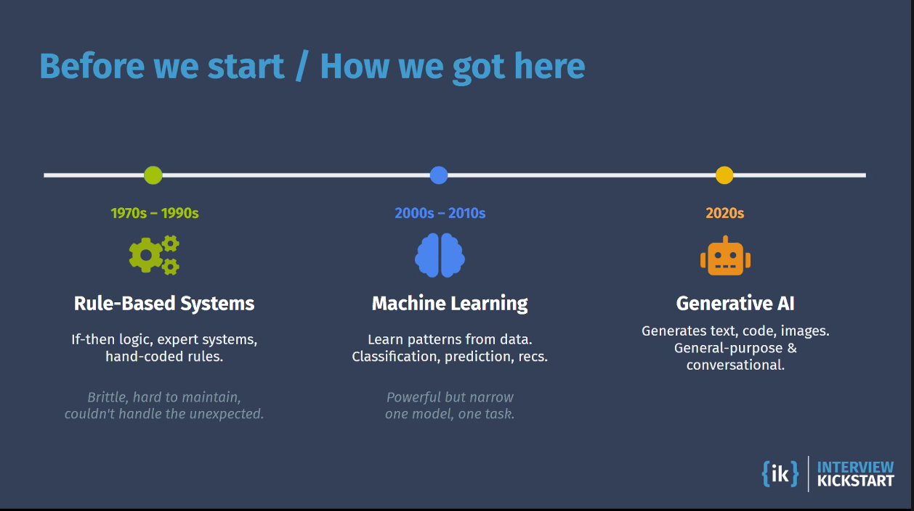
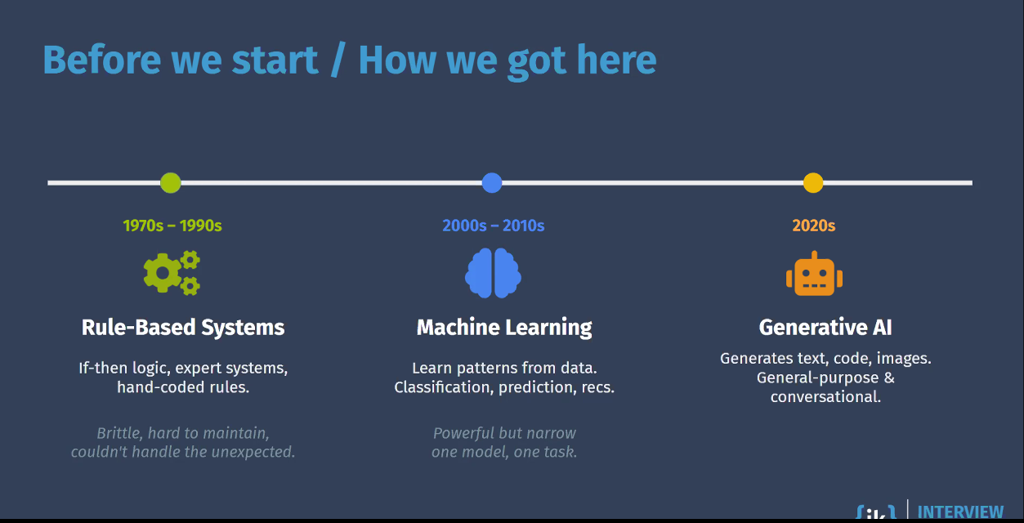
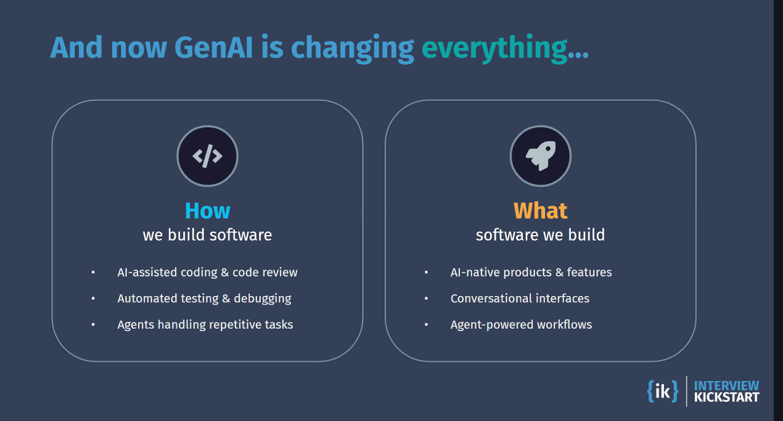

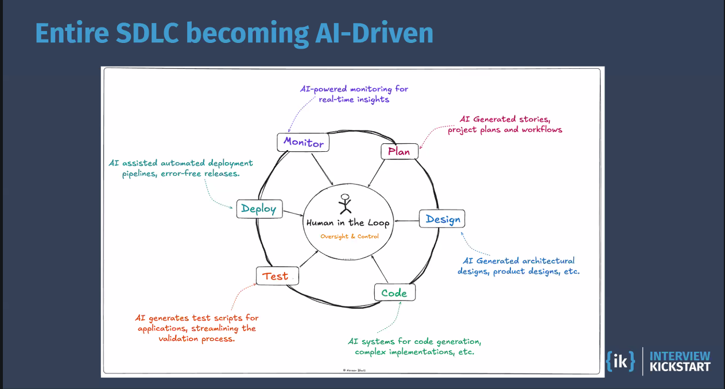
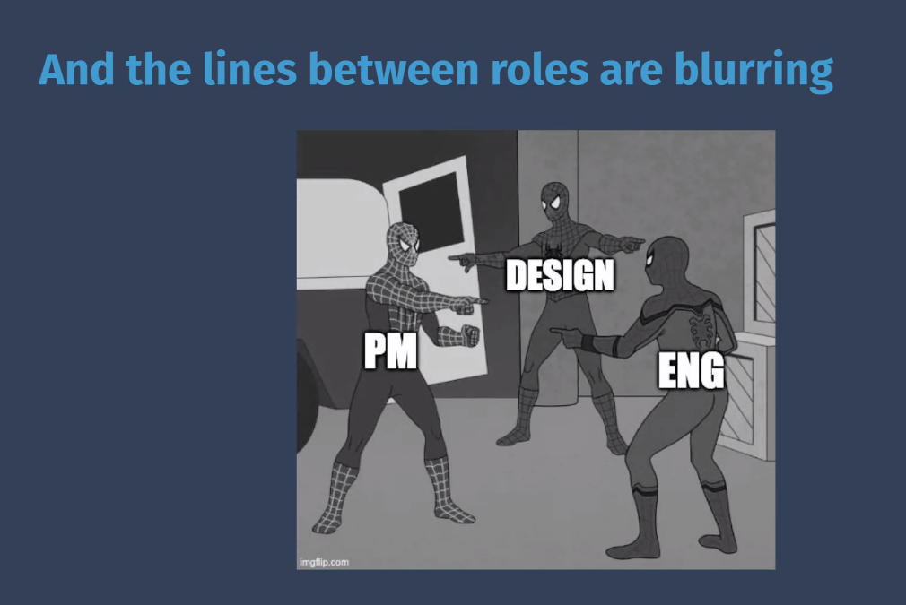
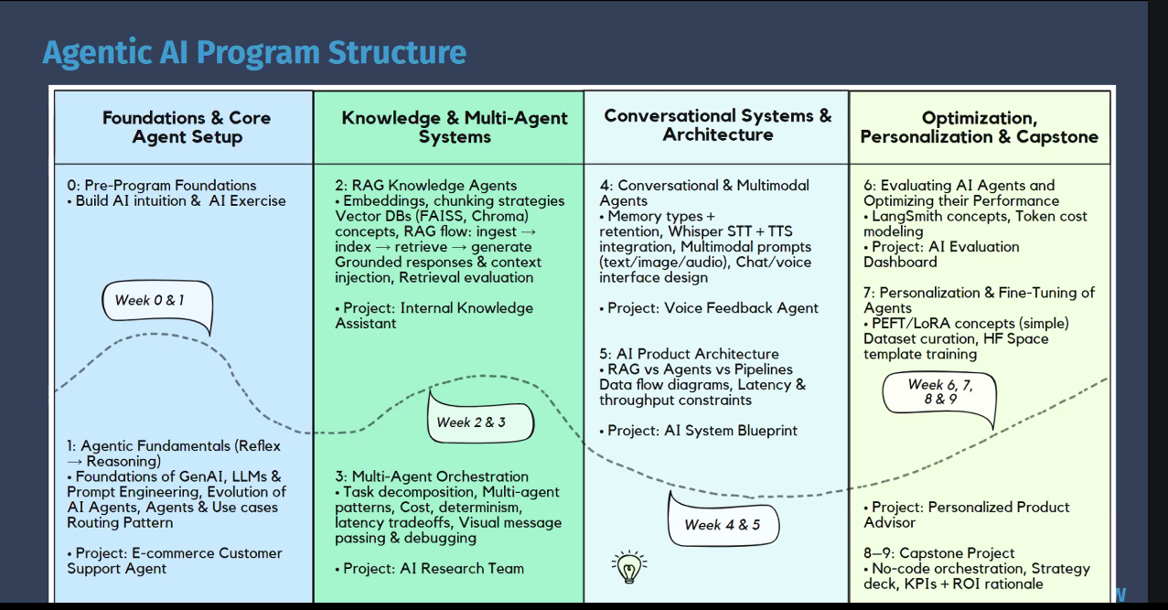

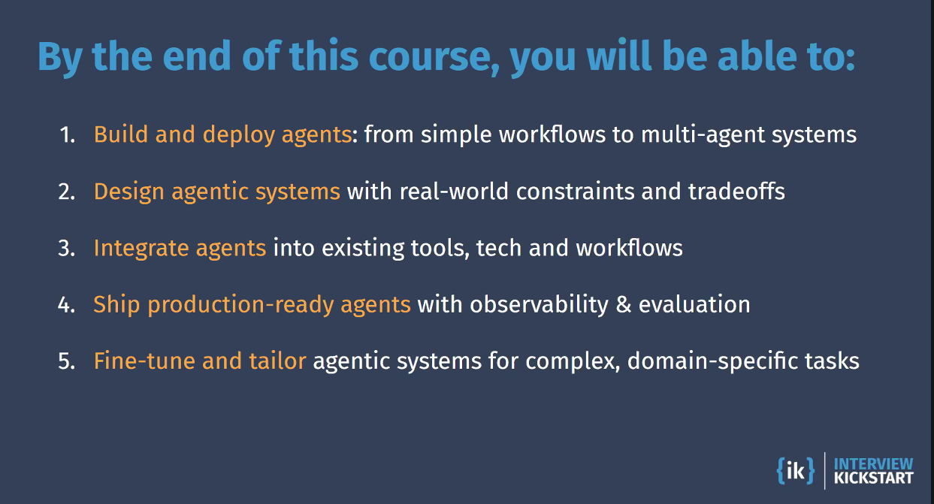
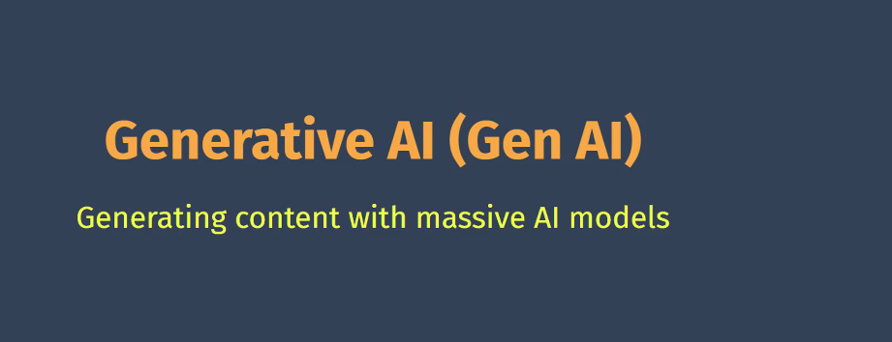
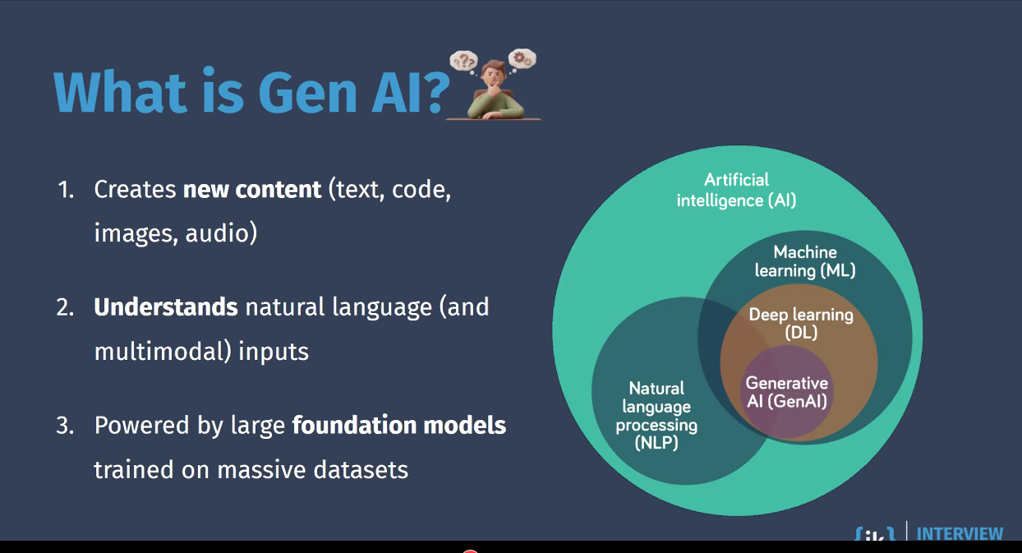
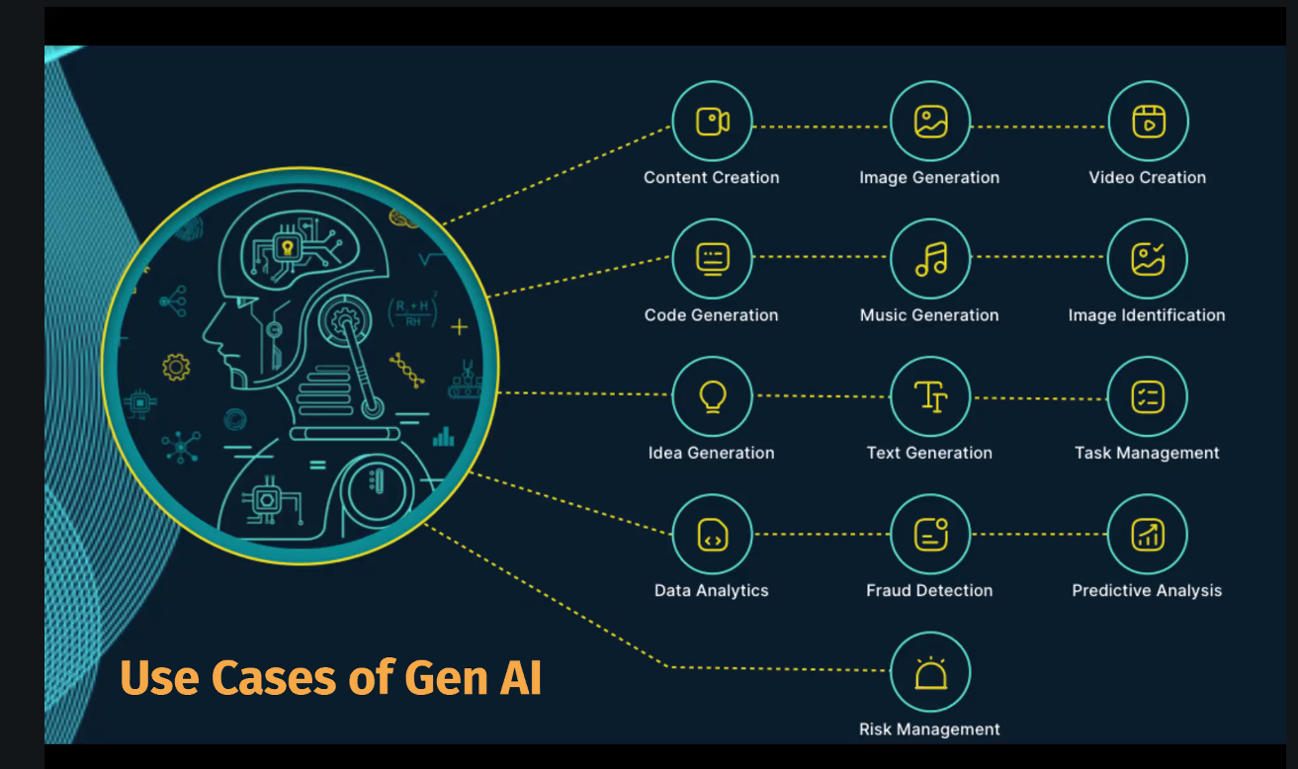
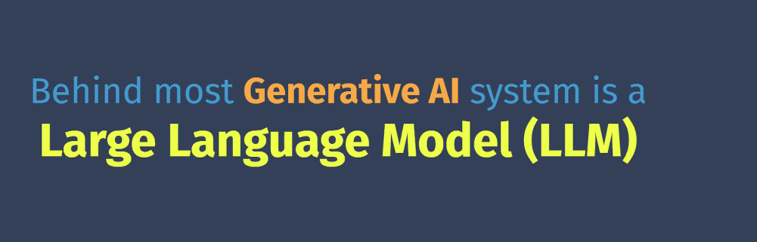
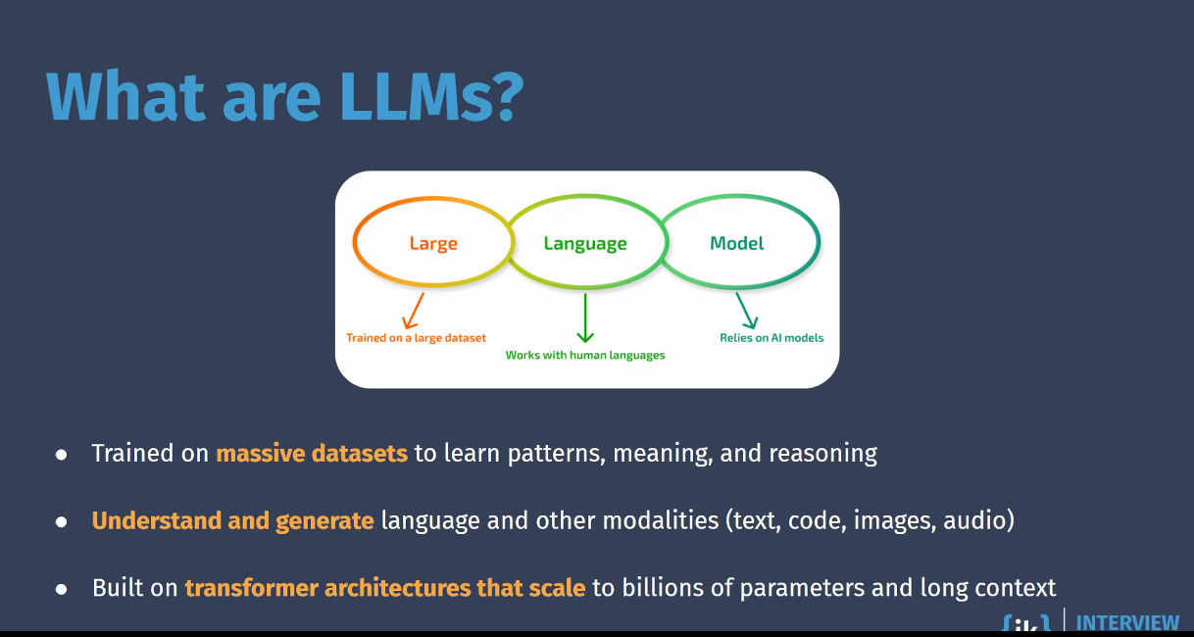
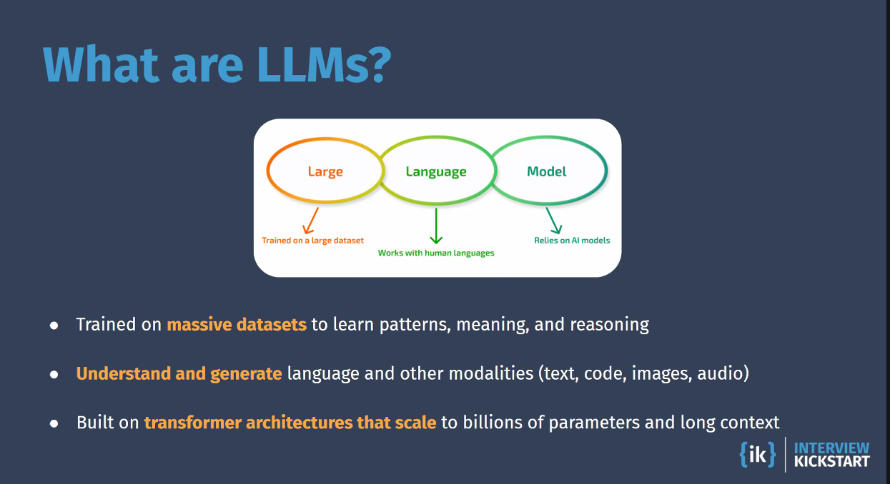
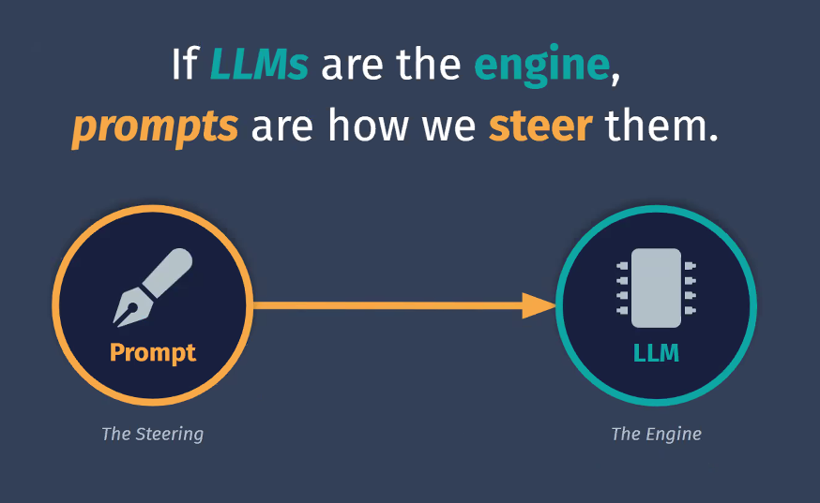
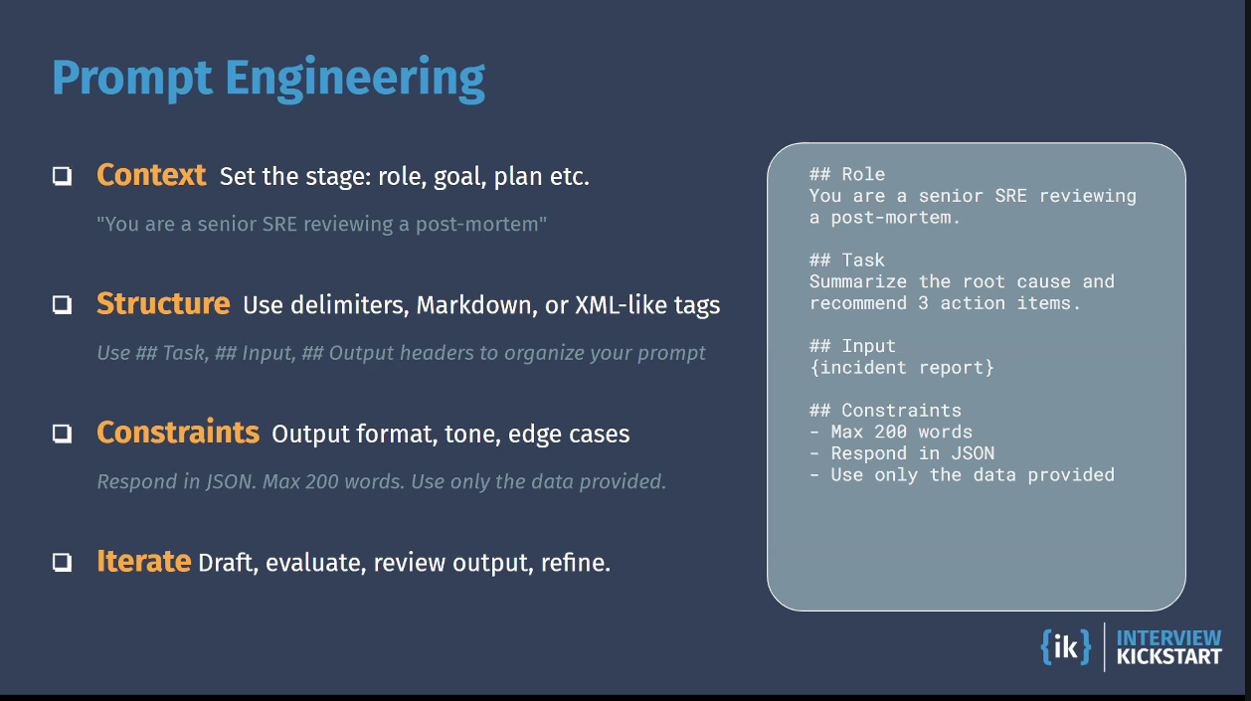
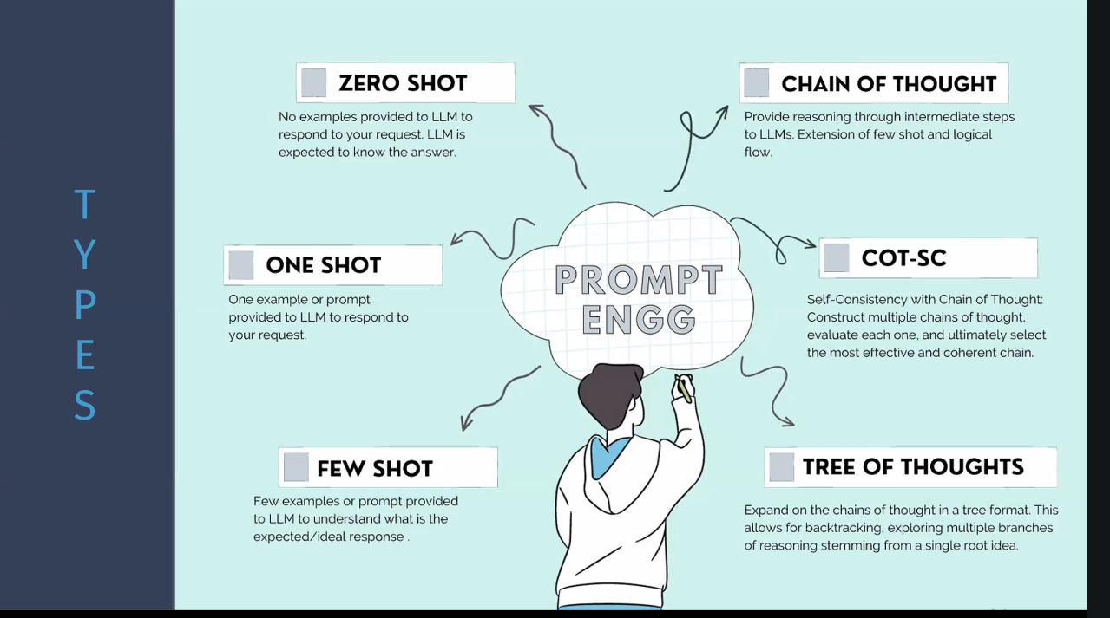
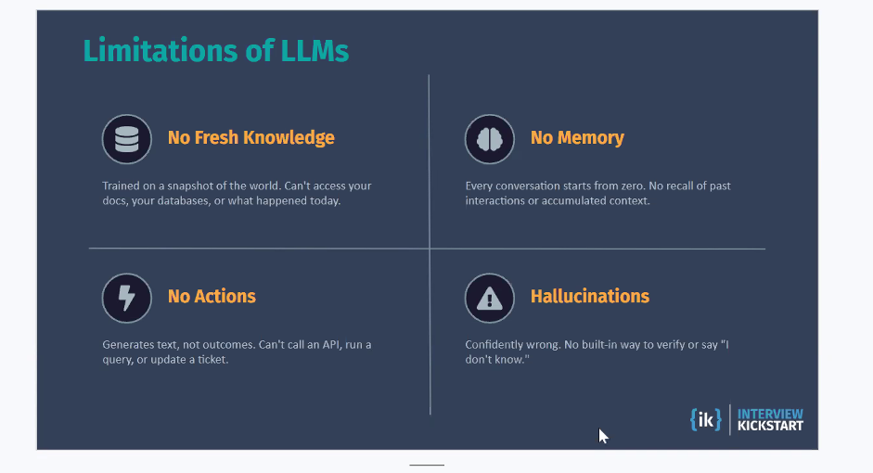
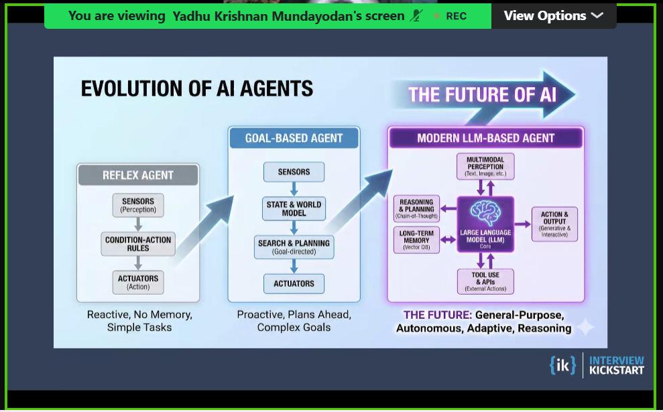
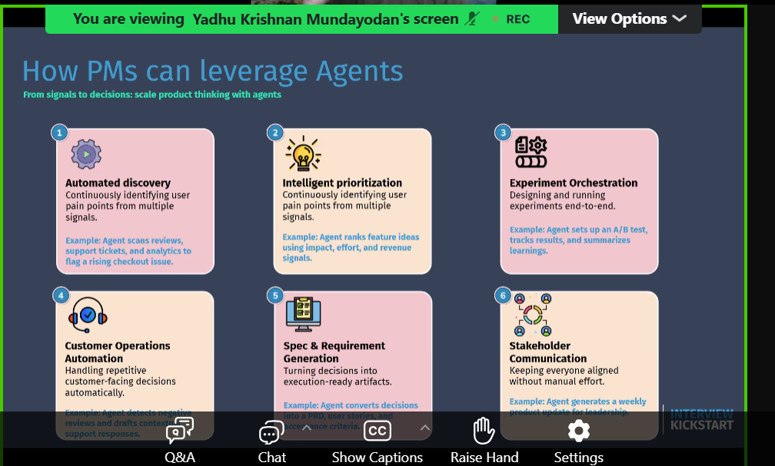
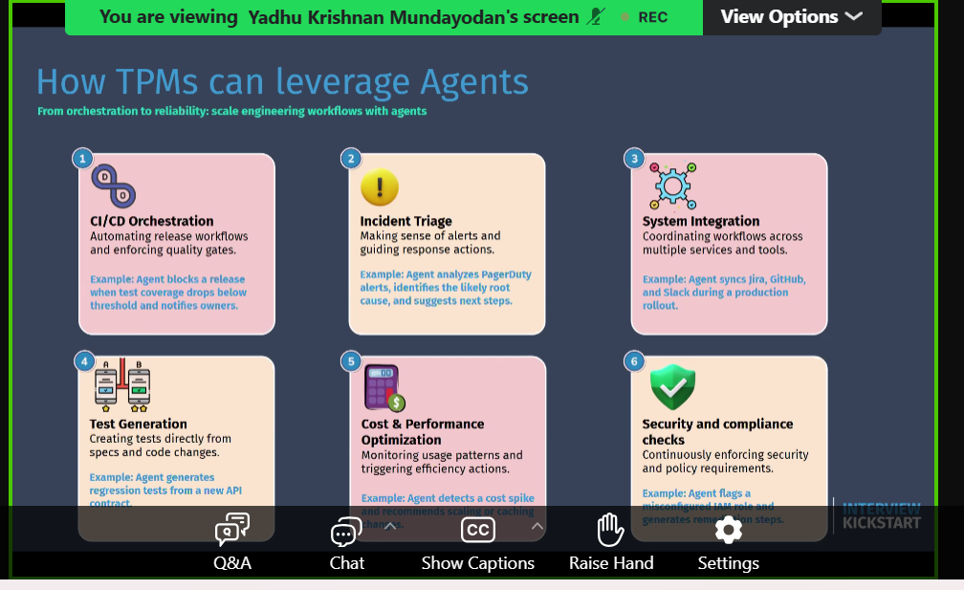
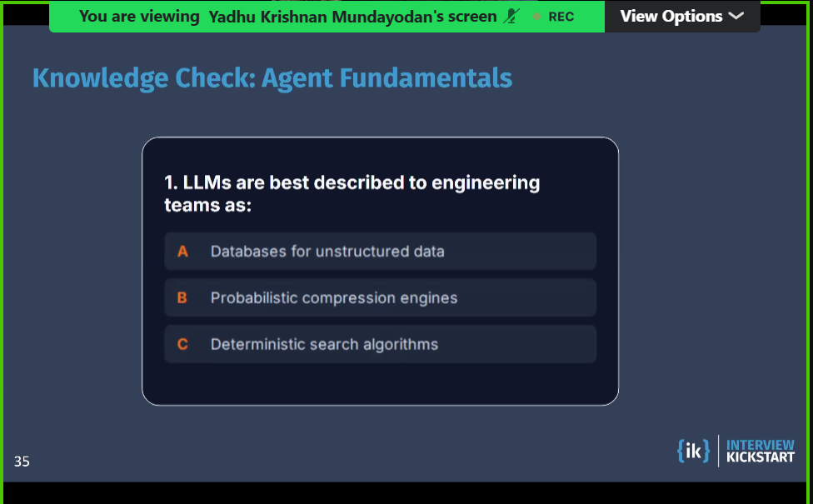

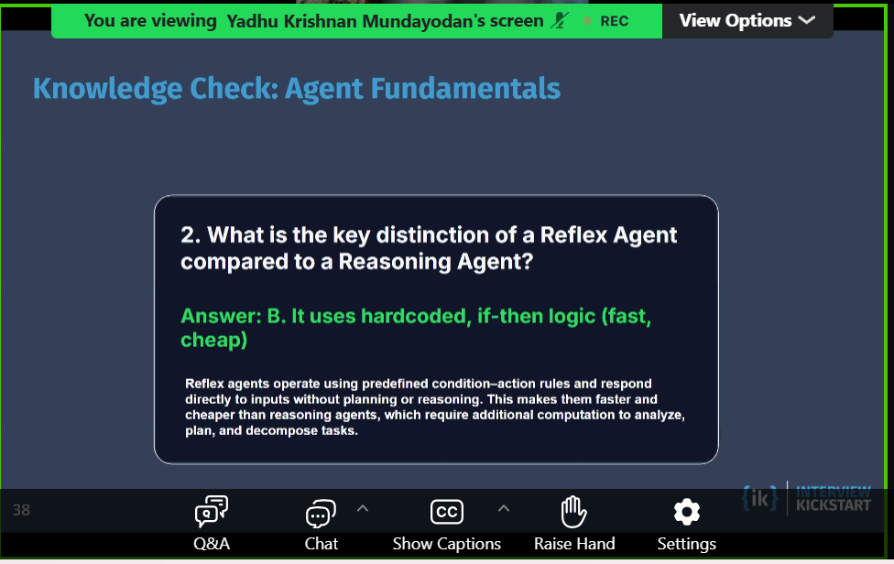
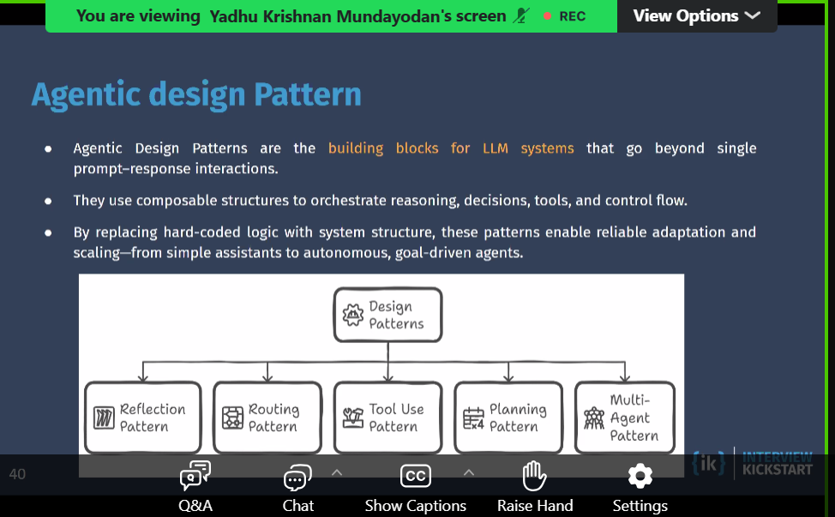
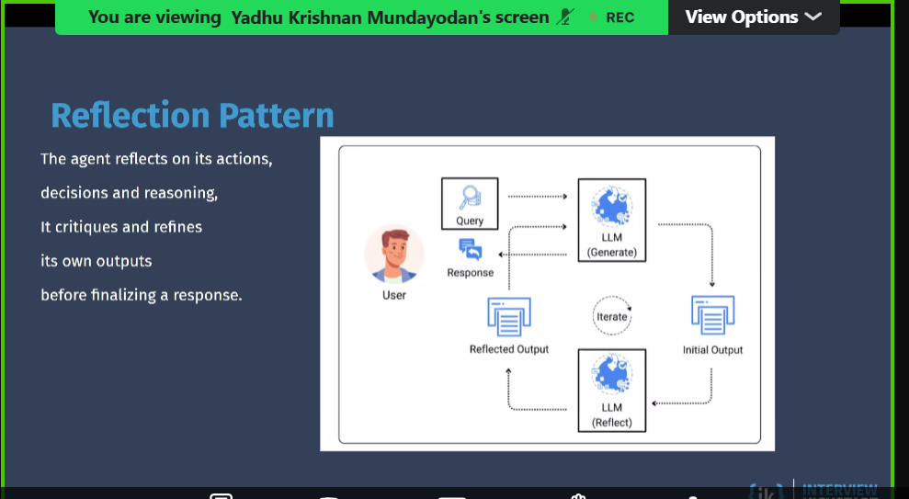
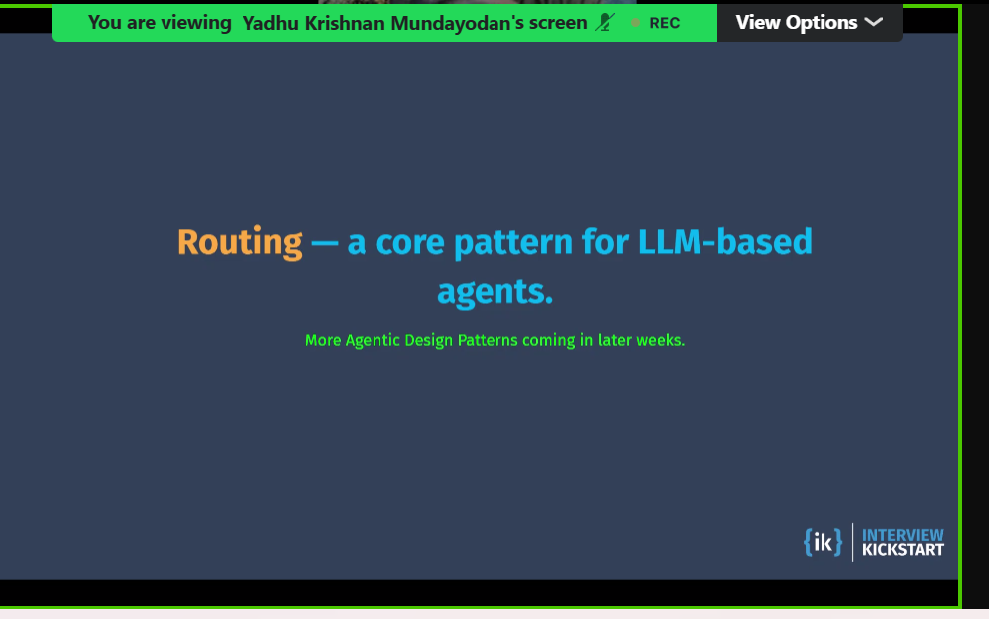
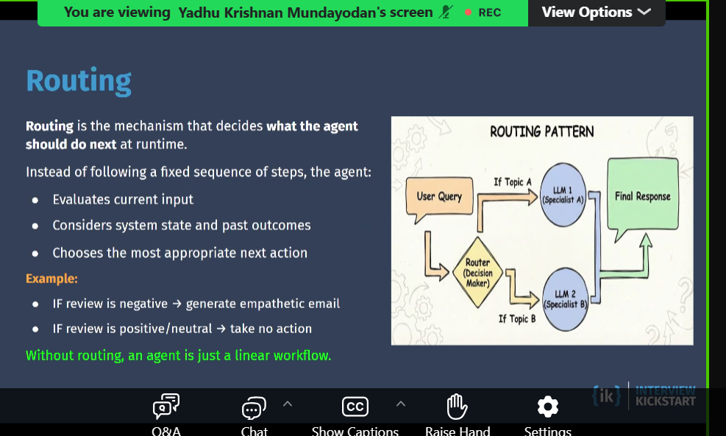
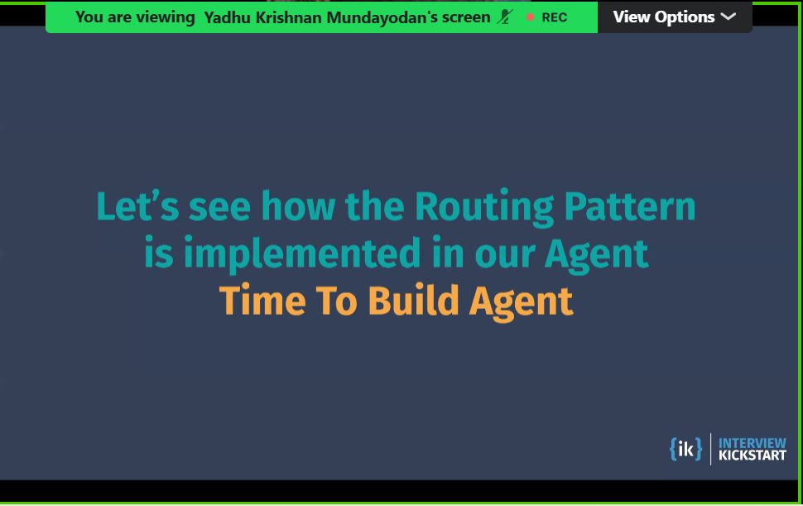

Native AI Product/company designed AI-first from day one. AI is core architecture, not a feature add-on. Example: AI coding assistant product built around model interactions. Generative AI AI that creates new content: text, code, image, audio, video. Usually powered by LL Regenerative AI Not a standard industry term yet. Commonly used to mean systems that self-improve/recover/adapt over time using feedback loops. In practice, teams usually describe this as: continuous learning, self-healing workflows, or adaptive agents. Agentic AI AI that can plan, decide steps, use tools, and execute tasks toward a goal. Goes beyond “generate one answer” into “do work across steps.” Example: read ticket, query logs, propose fix, open PR, draft update.
https://docs.google.com/spreadsheets/d/1P23rH06my9dTefqbpJ-iaBm6takuR4YFngoGoOmuCvo/edit?usp=sharing
https://docs.google.com/document/d/12QaVRvFDaJstDb3-AvI_3pXts-Al13lo/edit?usp=sharing&ouid=100860838215734057563&rtpof=true&sd=true

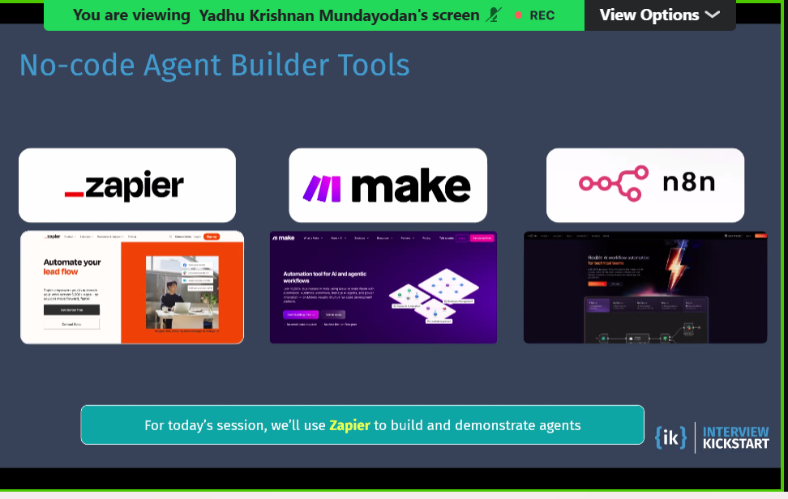
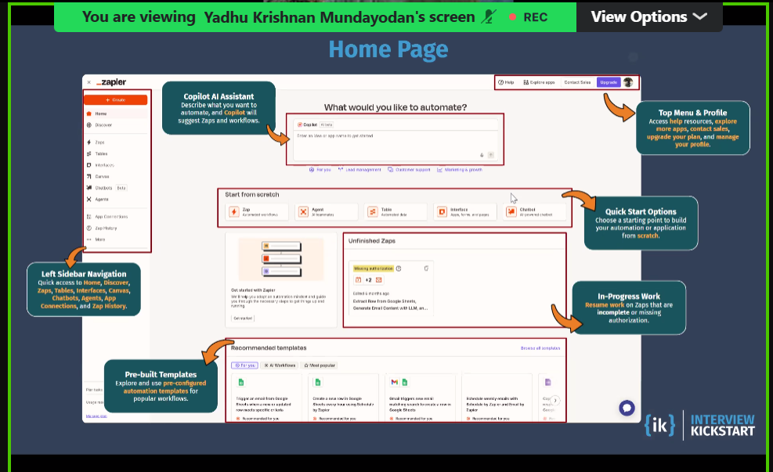
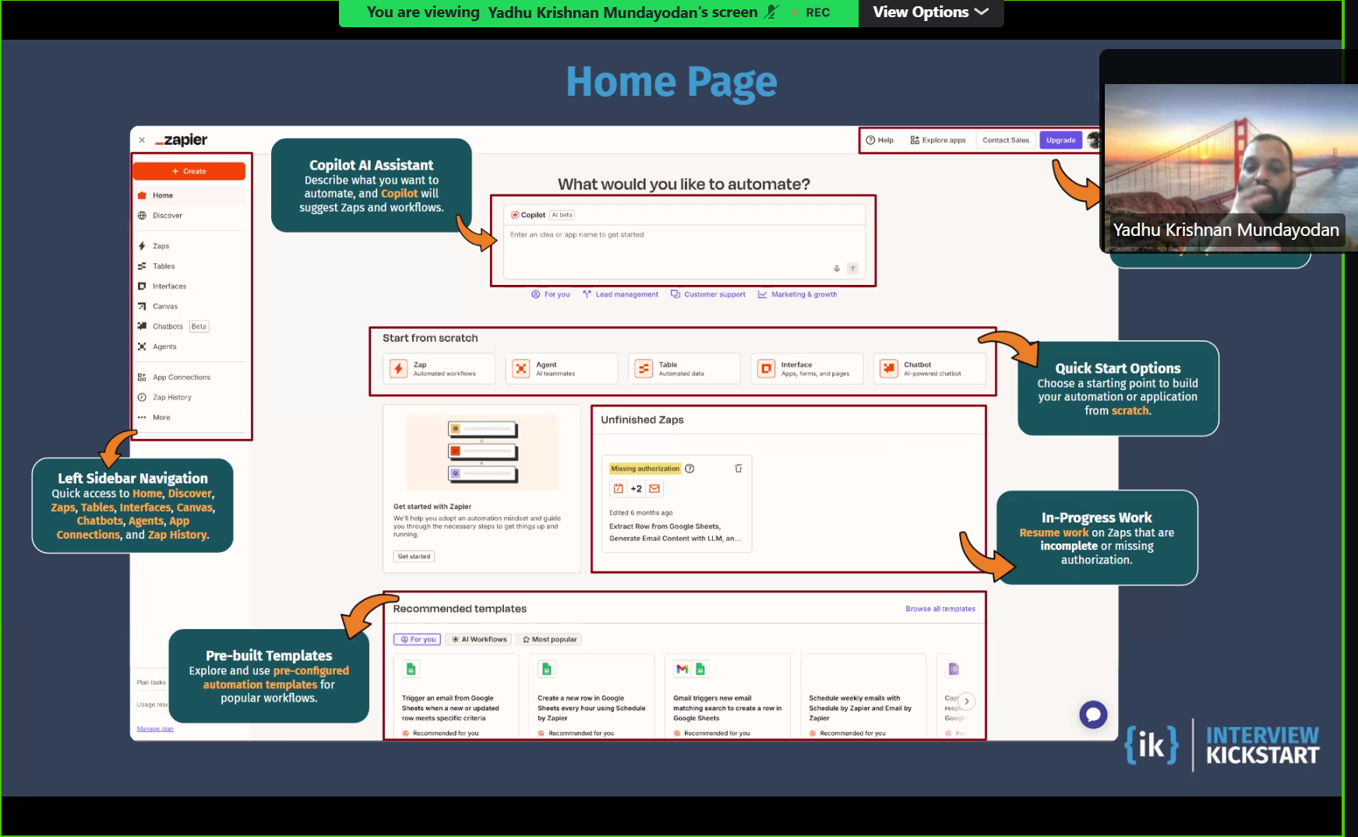
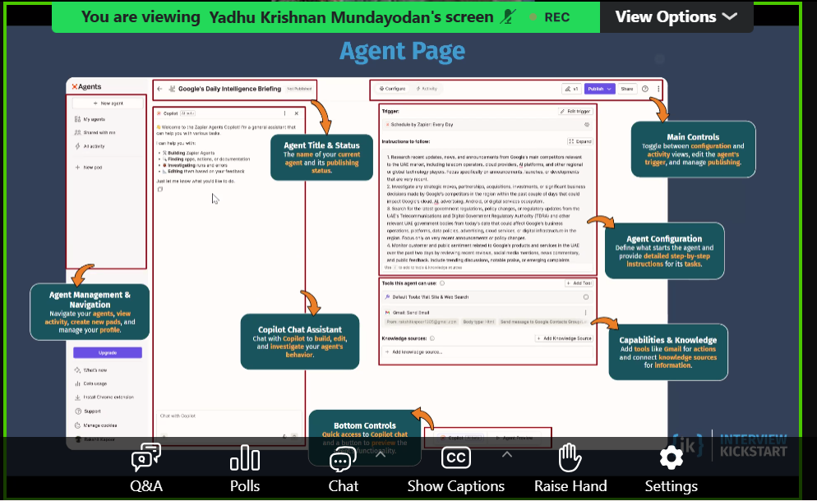
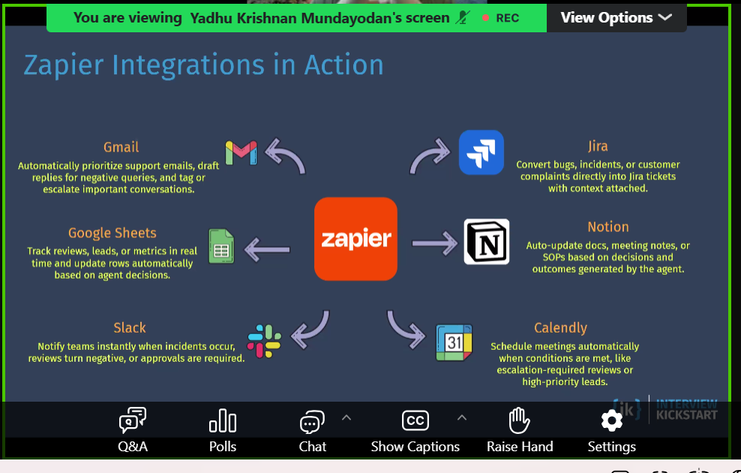
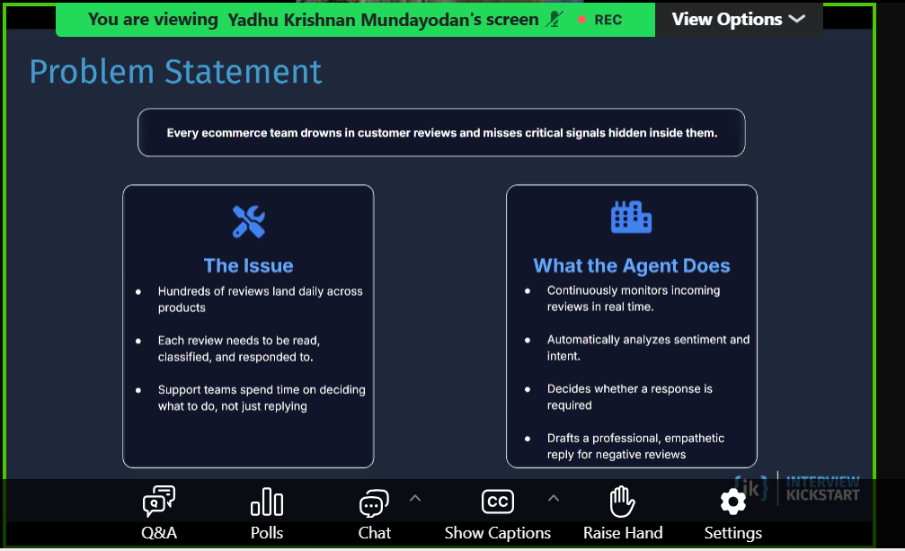
Native AI Product/company designed AI-first from day one. AI is core architecture, not a feature add-on. Example: AI coding assistant product built around model interactions. Generative AI AI that creates new content: text, code, image, audio, video. Usually powered by LL Regenerative AI Not a standard industry term yet. Commonly used to mean systems that self-improve/recover/adapt over time using feedback loops. In practice, teams usually describe this as: continuous learning, self-healing workflows, or adaptive agents. Agentic AI AI that can plan, decide steps, use tools, and execute tasks toward a goal. Goes beyond “generate one answer” into “do work across steps.” Example: read ticket, query logs, propose fix, open PR, draft update.
https://docs.google.com/spreadsheets/d/1P23rH06my9dTefqbpJ-iaBm6takuR4YFngoGoOmuCvo/edit?usp=sharing

